1. API call for Countries
   1. https://github.com/manumitsacademy/vlrreactb2/blob/ee060f23314ab1e71627306a6b32841c62182c84/src/Countries.js

**2.Create a clock using useState hook.**

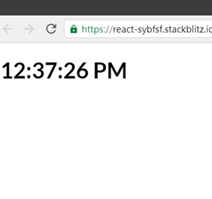

**3.Creating an Increment button using useState and useEffect to show alert after button click.**

